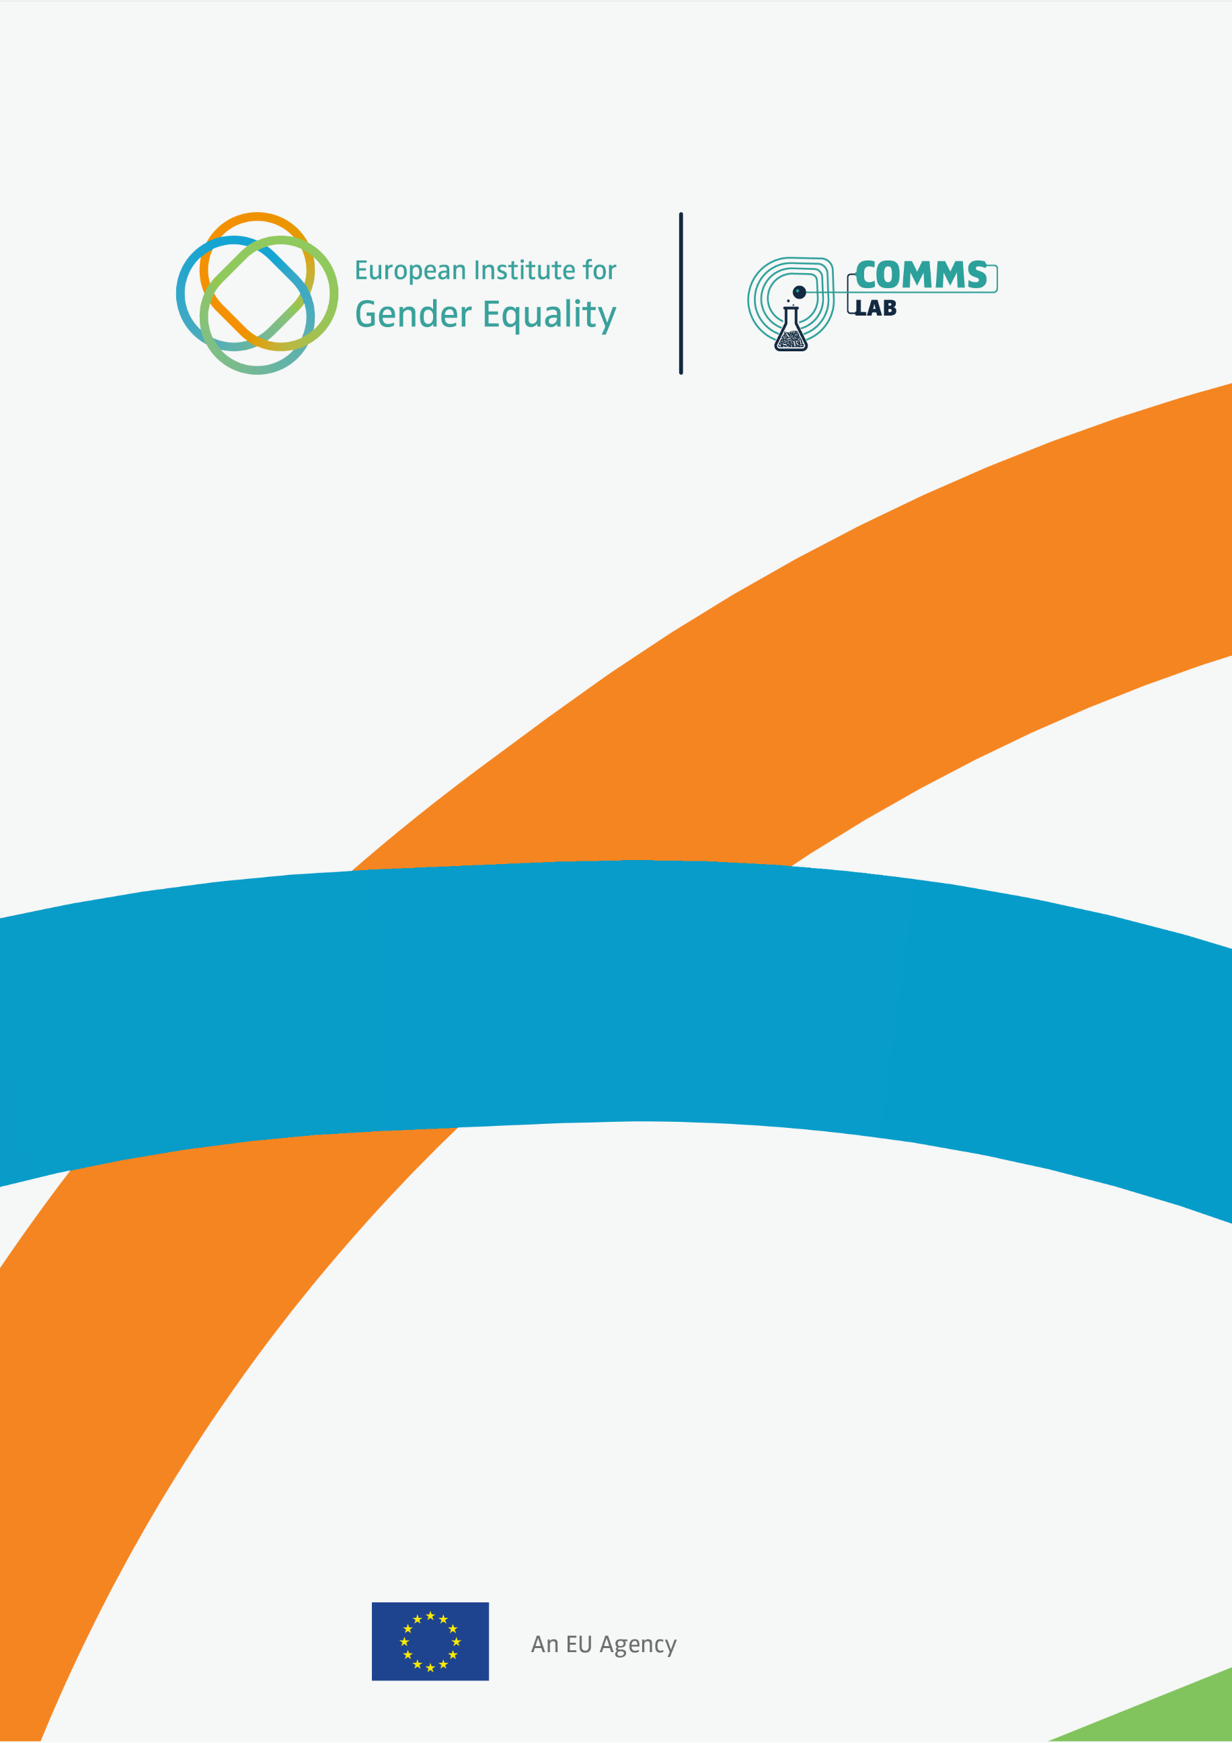

How to communicate for change

A workbook to help end violence against women

CONTENTS

What is violence against women? 2
How to use this book 4
Audience first 6
Shape your value statement 9
Narrative arc: Problem > Solution > Hope 11
Step 1 for your communication: Explain the problem 13
Step 2 for your communication: Outline the solution 15
Step 3 for your communication: Give hope 17
Communication planning 19
Communicate with care 21
Think ethically 23
Countering doubters 25
Dealing with misinformation and disinformation 28
Powerful openers 30
Picture power 31
Picture power: Avoid clichés 32
Activate your allies and time it right 33
Communication reflection 35

What is violence against women?
Violence against women is any act likely to result in physical, sexual, economic or psychological harm to women or girls. It is rooted in systemic gender inequality and power imbalances between women and men.
Violence can also take place online, through acts such as cyber harassment, image-based abuse or stalking, which often mirror and intensify offline violence.
Violence against women is one of the most severe and persistent human rights violations in society. Deep-rooted social norms, harmful stereotypes, and structural discrimination sustain it. Inequalities based on gender, race, migration status, disability, class, or sexual orientation can combine and increase women’s risk of violence or limit their access to support. Still, survivors demonstrate remarkable strength and resilience. Their voices are essential for shaping effective responses and building safer communities.
EIGE provides evidence to prevent and eliminate violence against women. We help policymakers design effective laws, policies and measures. We also promote a holistic approach, from early prevention to holding perpetrators accountable.
Violence against women takes many forms
Physical violence:  Harm inflicted as a result of unlawful physical force, including serious and minor assault, deprivation of liberty and manslaughter. | Sexual violence:  Any sexual act performed on a woman or girl without their consent. Sexual violence can take the form of rape (including attempted), sexual assault, sexual harassment, or exposure.
Psychological violence:  Any act that causes psychological harm to an individual. It can take the form of coercion, defamation, verbal insult or harassment. | Economic violence:  Behaviour that causes economic harm to an individual. It can be restricting access to finances, restricting access to education or work, property damage, or failing to comply with economic responsibilities.
Source: EIGE types of gender-based violence

The continuum of violence
Violence against women exists on a continuum. Different forms of violence are interlinked. They can happen simultaneously, offline or online, or at different stages of a woman’s life. Each incident reinforces the others, making the study of violence complex.
Violence against women doesn’t happen in a vacuum. Deep-rooted inequalities shape it, like everyday attitudes, stereotypes, and ideas about gender.
These beliefs can make violence seem normal or even justified. The systems and structures that reinforce them keep women at a disadvantage in work, in politics, and in daily life.

EIGE INSIGHT: A correlation of the EIGE Gender Equality Index with a flash Eurobarometer survey on gender stereotypes, found that stereotypes supporting violence against women are still commonplace across Europe. For example, 1 in 4 believe workplace sexual harassment is acceptable while 1 in 5 think women often exaggerate claims of sexual abuse or rape.


Introduction

How to use this book
This isn’t a rulebook. It’s a workbook.
It’s for anyone using communication to help end violence against women and girls.
Whether you’re writing a quick social media post, crafting a speech, or developing a full campaign, this is for you. Every message matters. Because better communication helps to show that a future free from violence is possible.
This workbook is designed for policymakers, campaigners and civil society organisations and anyone who communicates on equality and violence against women. Whether you’re working alone, or as part of a team, it aims to help sharpen your arguments and build effective, powerful communications.
Use it to think, sketch, plan, reflect and most of all, strengthen your message as an ally to end violence against women.
This book is designed to help you:
- find clarity in your messages,
- frame your arguments with confidence,
- push back against harmful narratives,
- and communicate with purpose and power.

Try this approach
1. Dip in and out | Start wherever feels most urgent for your work right now.
2. Make it your own | Use the blank spaces to draft, rewrite and refine your ideas.
3. Build your message as you go | Work through the exercises on your own, or as part of a group, to help construct a clear, compelling narrative.
4. Reflect and repeat | The more you practice, the more confident your messaging will become.

Remember: Your words can change minds, shift culture, and spark action. Use them well.

EIGE INSIGHT: Language and communication can have a powerful influence on gender equality. Our Words Matter guide offers example-based ways to make more gender inclusive choices across a variety of communication formats.

Notes

Audience first
Effective communication begins and ends with your intended audience. Before anything else, understand who they are and why they will care.
Define who you need to move and what are the barriers to their being persuaded.
Then you can tailor your tone, proof, and call-to-action to fit. This exercise helps you lay the foundations for crafting your values and narrative.
Not every audience needs the same attention. Focus your efforts on audiences where you are likely to have the most impact:
- The base: Already support you, so keep them motivated and equipped to speak out.
- Moveable middle: People whose views aren’t fixed but share values like safety and dignity. These people, with flexible or conflicted views, are most open to persuasion and empathy.
- Opposed: Some are determined not to shift their views. Address their arguments only when necessary to correct misinformation or protect others from its effects.

People whose views aren’t fixed and who share the values of safety, fairness and dignity respond to values-led messages with clear proof and doable actions.

Use the prompts below to build a quick profile for one priority audience.
Audience
Be specific when naming them, e.g. regional policymakers.

Pain points and barriers
What keeps them awake at night or prevents them from acting? For example, “competing priorities, limited budgets, pressure to show quick results”.

What drives them
Focus on one or two shared goals/values, e.g. “Fairness, community wellbeing”.

Where you’ll find them
List all the places they’re likely to see your communications, e.g. “LinkedIn, Politico”.

When to reach them
Consider key decision-making moments, not just awareness events, e.g. “annual budget meeting, drafting social policies”.

Pro Tip: Picture a real person from this audience, someone you could talk to. Use data and background research to fill in what drives or blocks them. If you don’t have perfect data, that’s fine, make your best, informed guess and refine it later.

Notes

Shape your value statement
A value statement is the heart of your communication. It’s more than a slogan or soundbite. It’s the guiding belief that explains why your actions to counter violence against women matter and what principle they stand on.
It can be written from your organisation’s perspective or tailored for a specific campaign, project or speech. The approach is the same.
When communicating about ending violence against women, your value statement helps you cut through denial, doubt or disengagement.
It reminds people that violence is preventable, and that change is both urgent and achievable. It shows the world we can build something better.
Your statement should be:
- Clear - say what you mean
- Rooted in values - like safety, dignity or justice
- Positive - focus on a positive future
This can inspire your audience and keep your messaging grounded.

Start by answering these prompts:
1. What are we trying to change?
This grounds your statement in a real problem. It’s the “why now?”

2. What principle or value is at stake?
The value (e.g. safety, dignity, justice) gets to the core of your message.

3. What does a better future look like?
This moves from problem to possibility and commits you to meaningful change.

Now, bring these together to draft your value statement. Try starting with phrases like: “We believe…”, “Everyone deserves…” or “A just society ensures…”.

Read it out loud. Does it feel bold and clear? Does it reflect your communication’s core purpose? Tweak it until it does.

EIGE INSIGHT: Every woman deserves to live free from violence, yet 1 in 3 women across the EU have experienced physical or psychological violence in their lifetime. Ending violence against women requires early intervention and strong prevention measures, alongside a robust response to hold perpetrators accountable. Guided by our mission to provide evidence and promote equality, EIGE works to uphold the values of safety, dignity and justice so that violence against women has no place in our societies.

Introduction

Narrative arc: Problem > Solution > Hope
The most effective communications for ending violence against women and girls follow a clear narrative arc. It’s a structure that storytellers use to keep a reader hooked.
One approach is to divide a story into three clear stages: problem, solution and then hope. This can form the basis for stories of any length: from social media posts to books.

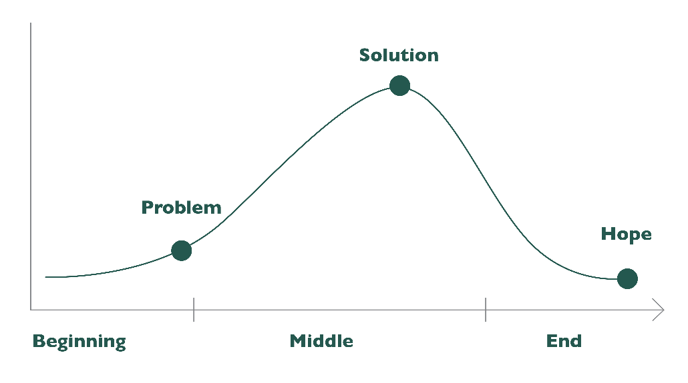

This structure works well for narratives focused on primary prevention of violence, such as:
- PROBLEM: Harmful gender norms lead to high levels of violence in relationships
- SOLUTION: Nationwide school programmes on healthy relationships and consent
- HOPE: The next generation can grow up free from violence and fear
The structure also works for narratives focused on response.
EIGE INSIGHT: Here’s how we applied this in our recent campaign to end sexual violence in the workplace:
- PROBLEM: 1-in-3 women experience sexual harassment at work
- SOLUTION: Employers adopting clear policies, safe reporting, and a zero-tolerance culture at work
- HOPE: A safe and respectful workplace for everyone

For more data and analysis to understand the scale of the problem we face, see the EU gender-based violence survey which was conducted by Eurostat, FRA and EIGE. There are also resources that point to solutions. EIGE’s Stop sexism at work toolkit provides recommendations tailored for EU institutions and agencies.

This structure helps readers understand what’s wrong, shows what they can change, and leaves them with a sense of possibility. You can see this process at play in the best campaign communications around violence against women.

Is there a campaign to end violence against women that inspired you? Try breaking it down into the three parts to see how the story was told.
Problem>Solution>Hope

Step 1 for your communication: Explain the problem
Now, let’s apply what we’ve learned to your own work.
Before people can care, they need to understand. Setting up the problem clearly, without jargon or blame, is one of the most powerful things you can do.
A well-explained problem doesn’t just describe what’s wrong. It helps people see why it matters, who it affects, and what needs to change.

Use these 3 building blocks:
1. What’s happening?
Stick to plain language. Be specific. Use one or two stats, not ten.
Example: Every day, women across Europe face violence in their homes, workplaces and communities - simply because they are women.

2. Why does it matter?
Show the human cost. Connect to values like safety, fairness and dignity.
Example: Violence against women shatters lives. It harms women directly, hurts their families and damages the fabric of society.

3. What’s stopping change?
Point to systemic barriers or cultural attitudes, not just individual actions.
Example: Despite laws and policies, harmful beliefs and a lack of enforcement mean that violence continues.

Now try putting it together into one strong paragraph that outlines the problem. Keep it tight. Then say it out loud: does it feel urgent, clear and grounded in real life?

EIGE INSIGHT: The suffering caused by violence is immeasurable, but its economic impact is staggering. Gender-based violence costs the EU €366 billion annually, with violence against women accounting for €289 billion of this total. Despite this, only 0.4% of the cost is allocated to shelters for women victims of violence, highlighting the urgent need for increased investment in protection and prevention efforts.

Step 2 for your communication: Outline the solution
Once you’ve explained the problem, your reader will be asking: “So what can we do about it?”
This is your opportunity to offer clarity and direction. When you outline a strong solution, you help people see a path forward.
A strong solution is concrete and empowering.
Now, let’s think about these questions:
1. What specific change are we calling for?
Example: Funding for survivor support services, education in schools on respect, equality and consent, programmes to change attitudes, legal changes?

2. Who has the power to make this change?
Example: Is it the government and parliaments? Men and boys as agents of change? Schools and educators? Employers and media outlets?

3. What action do we want our audience to take?
Examples: Sign a petition? Share a story? Change the behaviour of those witnessing violence against women? Pressure decision-makers?

Now draft your solution statement
Try this simple formula: “To [end/prevent/improve] [the issue], we need [specific solution]. This means [who] must [action or change].”
Keep it focused, realistic, and hopeful.

EIGE INSIGHT: To effectively combat cyberviolence, EIGE supports the adoption of clear definitions for its various forms. This ensures all stakeholders, from policymakers to law enforcement, have a shared understanding of the issue, enabling more targeted and effective interventions.
To raise awareness about the different types of cyberviolence and foster a safer online environment for everyone, EIGE developed the “Safe spaces” campaign, highlighting how cyberviolence can start online and continue offline, or vice versa.

Step 3 for your communication: Give hope
Once you’ve explained the problem and outlined the solution, don’t stop there. You need to show that violence is not inevitable. It’s preventable. Hope is what turns awareness into action.
What does hope look like in your communication? Consider how you can show progress towards ending violence against women and the resilience of people making real change.
Survivors’ courage and leadership offer some of the most powerful examples of hope. Their lived experience can guide better prevention, stronger support, and lasting change.

1. What signs of progress or success can you highlight?
Example: Past wins, public conversations on consent, prevention programmes, survivor-led advocacy changing policy, grassroots action?

2. Who is already making a difference?
Mention individuals, organisations, or movements leading the way.

EIGE INSIGHT: It’s important to look at areas where solutions are already working. EIGE shows what a brighter future could look like by highlighting promising practices from EU Member States. These include strengthening the role of gender equality bodies in crisis management and ensuring meaningful engagement of civil society.

3. What will the world look like if we succeed?
Describe the future you’re working towards — safety, dignity, equality.

EIGE INSIGHT: As part of strategic foresight exercises, we consulted experts from governments, businesses, and policy and advocacy groups to identify major gender equality issues for the next 15 years. They identified five key themes: digitalisation, the green transition, the future of work, diversifying inequalities, and shifting values. The digitalisation theme highlights the importance of inclusive digital policies to ensure equitable access and protect against online harassment.

Now, write a hopeful closing statement. Use language that is clear, courageous and forward-looking.
Consider phrases like “Change is possible because…” / “Together, we can…” / “We’ve done it before, and we can do it again.”

Finally, write your call to action. Don’t leave your audience wondering what to do next; give them direction. A good call to action should be specific, achievable and motivating.
Give an order and do it with a sense of urgency. For example: “Sign this petition to protect women’s shelters”, or “Share this story to break the silence.”
Now, you try.

Remember: People want to help. Your job is to show them how.

Communication planning
1. The REC planning tool
Good communication connects with both the heart and the head—but it should lead with the heart. That’s because people tend to make decisions based on how they feel, then justify, or post-rationalise those decisions with facts.
So, when you’re planning what to say, don’t just focus on the rational case. Make sure you’re also creating an emotional connection—and always finish with a clear call to action.
Use this REC planner to help you shape your message:

R – What’s the Rational case you want to make?
List everything you want your audience to know. That could be data, dates or critical events.
Example: Germany’s Stärker als Gewalt campaign shared facts showing how many victims of domestic violence face barriers to getting help, highlighting the scale of hidden violence.

E – What’s the Emotional connection?
What do you want your audience to feel? How can they make a human connection with the story?
Example: Spain’s “Ahora ya, España es otra” campaign uses an anthemic song, real stories, and cultural flashpoints to show that gender-based violence is no longer tolerated and make audiences feel that change is possible.

C – What’s the call to action?
What do you want them to think or do differently as a result? Make it a simple, direct command, such as SIGN UP NOW or SHARE WITH YOUR NETWORK.
Example: Austria’s “Mann spricht’s an” campaign urges men to break the silence: spot warning signs, speak up, and step in when they see violence or abuse.

2. Three key messages
Before writing anything (a press release, speech or social post) you need to be clear on your key messages. List three points you want your audience to remember, repeat, and act on.
Why three? It gives your writing rhythm and it’s easy for your audience to remember.
Key message 1

Key message 2

Key message 3

Now ask yourself: Do these messages feel clear, hopeful and grounded in facts? If not, rewrite until they do.

Communicate with care
When discussing violence against women, words matter. They can hurt or heal. They can reinforce the stigma or break the silence. They can blame or empower.
As a communicator, your job is to speak with truth and compassion, to raise awareness without causing harm and to invite action without reinforcing fear.
Before you hit publish, run through this checklist:
- Am I centring the survivor’s dignity and agency? Have I avoided language that objectifies, sensationalises, or blames?
- Am I using clear, direct, gender-sensitive terms, not euphemisms? For example, do I talk about “violence against women” rather than “domestic issues”?
- Have I avoided graphic or triggering details? Did I focus on the impact and the response and not the violence itself?
- Am I making space for empathy and understanding? Did I challenge harmful myths gently but firmly and speak to people’s values?

Words to use with intention
Language isn’t neutral. Some words can shift the tone of your entire message, for better or worse.
Communicate as though the person who is listening has lived through violence. Consider alternatives to words you think might result in harm.
We’ve kept the list of examples short on purpose. The words that work for one organisation, audience, or Member State may not work for another.
That’s why we encourage you to use this section as a starting point, not a script. Talk it through with your colleagues. Ask yourself:
- What language reflects our values?
- What terms might unintentionally cause harm?

Use this space to spark internal discussion and shape messaging that fits your context and your community.
Instead of this… | Write this…
Lover/ex/jealous boyfriend | Perpetrator or (former) intimate partner
Rescue/protection | Support/access to justice
She stayed with her abuser | Her controlling abuser prevented her from leaving

EIGE INSIGHT: EIGE’s research shows that serious barriers remain in how EU countries collect and publish data on violence against women. Inconsistent definitions mean that many femicides remain hidden in general homicide statistics and few countries publish the breakdowns needed to monitor responses to intimate partner violence. These gaps make it harder to hold perpetrators accountable and to design effective policies.

Think ethically
When communicating on violence against women, ethics aren’t just a side note, they should be front and centre.
You’re working with people’s lives. That requires responsibility, respect and care.
Use this checklist to think through the ethical dimensions of your communication before you deliver it. It will help keep your message ethical, respectful, and impactful.

Privacy & consent
- Have I gained clear, informed consent to share personal stories or images?
- Have I protected the identity of survivors where necessary?
- Am I respecting boundaries of the person whose story I’m telling?

Dignity & representation
- Does my language centre the agency and dignity of women and survivors?
- Have I avoided sensationalism, victim-blaming, and stereotypes?
- Is the message inclusive of diverse experiences and identities?

Transparency & accuracy
- Am I using facts from reliable, gender-sensitive sources?
- Is it clear who is speaking and on whose behalf?
- Have I been honest about the purpose of the communication?

Unintended consequences
- Could this message retraumatise, alienate, or offend the people I want to support?
- Could it be easily misused or misinterpreted by opponents?
- Have I tested this with someone outside the core team?

Final check
- Would a survivor feel seen and respected by this message?
- Would I be comfortable defending this message in public?
- Does this communication challenge perpetrators and inequalities, or place the burden on women to keep themselves safe?
- Does this communication build trust, not just visibility?

Keep this checklist visible during planning and review sessions. Ethics are a shared responsibility.

Countering doubters
1. Objection/Overcome/Evidence
When talking about violence against women, you’ll encounter questions. These might range from genuine concerns to anti-gender pushback. How can these all be addressed?
In our analysis, one of the most common questions is: “Focusing on violence against women ignores male victims” or simply “What about men?”.
We also often found that anti-gender narratives play on racist and Islamophobic tropes, relating violence against women to migrants.
You’ve surely heard many other doubts and objections. Now, imagine sitting face-to-face with the person challenging you. How would you calmly, confidently persuade them?
In the first column, write their objection. Next craft a clear, empathetic response to help them see things differently. In the final column, list evidence that supports your response.
Use the completed table to strengthen future messaging.

Objection | Overcome | Evidence
The problem of violence against women is exaggerated. I have never seen it. | Violence is often hidden behind closed doors, online or unreported. That doesn’t mean it isn’t real. | 1 in 3 women in the EU experience physical or sexual violence. Yet only 1 in 8 have reported it.  See the EU gender-based violence survey
What about men? Don’t they also face violence? | Men experience violence and their safety matters. But women face higher risk of repeated, severe, and sexualised violence, often from a partner.  Understanding the different patterns helps protect everyone. | Women make up 87% of intimate partner violence victims, 60% of domestic homicide victims, and 42% of all homicides.  Source: EIGE policy brief on femicide
Isn’t violence against women mostly caused by migrants? | Violence against women happens in every country and community. It is rooted in gender inequality, not nationality. Putting a focus on migrants fuels harmful stereotypes and distracts from real solutions. | The EU gender-based violence survey shows that most sexual violence happens within intimate relationships. More women report rape by a partner (6.9%) than a non-partner (3.8%). National differences are small and don’t support putting a focus on migrants.
Talking about violence against women divides society. | Speaking out unites us, while ignoring injustice can tear communities apart. | Higher gender equality links to higher disclosure of severe violence (e.g. Nordic states). Where equality is lower, patterns are shaped by complex social and cultural factors.

2. Reframing false choices
Anti-gender narratives often rely on false choices presenting two extreme, opposing options and pretending there’s no middle ground. Your job as a communicator is to notice these traps and reframe the conversation.
When someone says, “It’s either this or that”, you need to show there are other possibilities.

False choices I heard | How to reframe | EIGE INSIGHT
Feminists are against men. | Gender equality benefits everyone. So, both women and men are free to live without fear or limits. | Gender equality benefits all. Shared childcare increases satisfaction for women (70%) and men (73%). Greater equality could raise EU GDP up to €3.15 trillion by 2050.  Sources:  EIGE news article  Economic benefits of gender equality report
Silencing hate is anti-free speech. | Hate shuts down conversations. Free speech thrives when everyone feels safe to speak, not just the loudest or angriest voices. | Women are the main targets of online hate. Cyberviolence silences and excludes them from digital spaces. Policies can help support a safe environment for all. For example, EU Directive 2024/1385 criminalises online harassment and calls for stronger cyber safety.

PRO TIP: When reframing, lead with values: fairness, dignity, safety, community, etc. Follow with facts - and finish with hope.

Dealing with misinformation and disinformation

Misinformation is false or misleading content that is shared in good faith.

Disinformation is false or misleading content spread with deliberate intent to deceive.

Gendered disinformation specifically targets women, or LGBTQIA+ people.

Disinformation weaponises misogyny and stereotypes. It’s often aimed at those in public life such as journalists, activists, and politicians. It can be used to attack equality and equal-pay policies or to deter participation and weaken democracy.
When challenging anti-gender narratives or disinformation about violence against women, the way you respond matters as much as the facts themselves.
Repeating a myth, even to debunk it, can reinforce it. So, instead of myth busting, try the Truth Sandwich.
It’s a technique developed by the linguist George Lakoff and used by journalists to correct disinformation without giving it more oxygen. It helps you counter a lie without amplifying it.
The Truth Sandwich
- Start with the truth. Don’t start by repeating a falsehood, lead with what’s accurate.
- Indicate the lie. Briefly describe the false claim, but don’t echo its harmful language.
- Return to the truth. Reinforce the facts and values you want people to remember.

Now try it yourself. To help you fill your own Truth Sandwich, we use the example of disinformation claiming “Online abuse isn’t ‘real’ violence”.
Top slice: What’s the truth?
Example: Cyberviolence silences women and girls pushing them out of public life.

The myth (describe it without repeating harmful language)
Example: Some people wrongly dismiss online abuse as just words.

Bottom slice: Reaffirm the truth and shared values
Example: Everyone deserves to feel safe on and offline. Taking abuse seriously, reporting it and supporting victims helps build a digital space grounded in respect and equality.

People trust you more when they feel informed, not manipulated. Stick to what’s true, say it clearly, confidently, and often.
PRO TIPS
- Lead with values: safety, dignity, fairness, equality
- Keep the falsehood brief - don’t give it more airtime than the truth
- Repeat truths more than you mention the myth

EIGE INSIGHT: Online disinformation and misinformation about gender equality and violence against women is growing. EIGE’s work on digital safety and cyberviolence highlights how false narratives can normalise violence and undermine women’s safety online.

Powerful openers
“A writer only begins a book.
A reader finishes it.”
– Samuel Johnson
When writing about violence against women — especially in a noisy, distracted world — grabbing your reader’s attention from the very first line is essential. Journalists use openers to make readers stop, look, and want to keep reading. You can do the same.
What follows are five tried-and-tested hooks. Think about how you might use them and jot down great examples from other writers.

Anecdote Opener: Tell a short, human story that makes your reader care.
Example: Maria never thought she would be hurt by the person she loved.
Statistic Opener: Start with a fact that shocks or surprises.
Example: One in three women in the EU will experience physical or sexual violence in their lifetime.
Quotation Opener: Use a memorable quote to add weight/insight.
Example: “Violence against women is a global emergency, yet too often invisible.”
Question Opener: Ask something open-ended that sparks curiosity.
Example: How can we shift the conversation to prevent violence against women before it starts?
Statement Opener: Make a bold claim that demands attention.
Example: Ending violence against women is possible, but only if we stop making excuses.

Picture power
A picture is worth a thousand words. Choose the wrong image to illustrate your communications and you can send the wrong message.
The human brain processes a picture in as little as 13 milliseconds. That means your reader is starting to form an opinion before they’ve read a single word.
And first impressions count.
Visuals set the emotional tone, shape understanding, and strongly influence how your message is received (or rejected).
They can show dignity or despair. They can challenge stigma or reinforce it.
That’s why it’s so important to choose visuals that match the purpose, tone and values of your message.

Ask yourself:
- Does this image centre the survivor’s dignity and strength?
Avoid showing women as broken or passive. Focus on resilience, solidarity, and agency.
- Have I avoided stereotypes and clichés?
Generic stock photos of a crying woman or a clenched male fist can reduce complex issues to tired tropes. Be specific. Be thoughtful. Be human.
- Does the image reflect the diversity of real experiences?
Violence affects women and girls of all ages, ethnicities and identities. Representation matters.
- Is the subject identifiable? Have I considered their privacy?
If using real stories or people, make sure you have full informed consent and that the person understands how their image will be used.
- What emotion does the image evoke? Is that the emotion I want my audience to feel?
Choose visuals that inspire empathy and hope, not fear or pity.
- Does the image support my message or distract from it?
Don’t let visuals overwhelm your words. They should work together, not compete.

Picture power: Avoid clichés
Overused imagery | Try instead
Shadowy figures or bruised faces | Images depicting emotionally charged interactions to illustrate emotional abuse
Isolated women in distress | Images of community, support services, or positive action
Angry men in aggressive poses | Photos that point to solutions: education, justice, prevention

Final check:
Would a survivor feel respected and seen if they viewed this image?
Would the image make someone feel informed or ashamed, fearful or hopeless?
When in doubt, pause. Talk it through with colleagues. Let your values lead the way.

EIGE INSIGHT: When illustrating the results of the EU Gender-based violence survey FRA and EIGE created a suite of inclusive, dignified line drawings to avoid retraumatising imagery and shift the visual narrative. Do you think these worked?
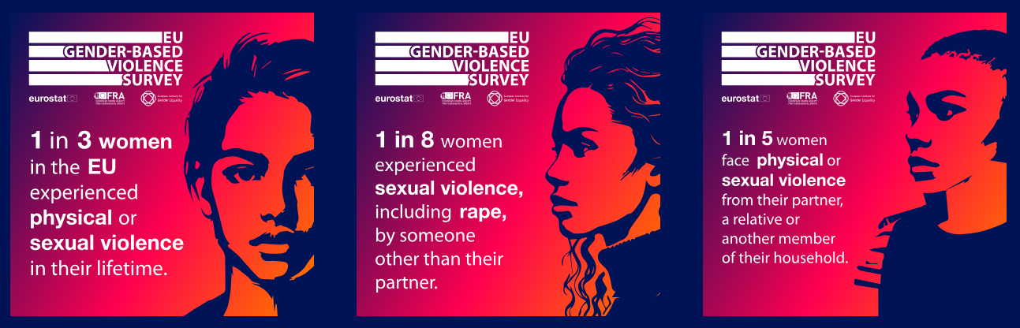

Activate your allies and time it right
The most powerful communication on violence against women is backed by communities, not just individuals. You don’t have to do this alone!
Building a network of allies means more voices and more reach. So, when you share your message, it has more impact and travels further.
Build your community.
Who shares your values on violence against women? Who has reach, credibility or influence? Who can help you get your message out?

Ally/Organisation | How they can help (e.g. share, fund, co-host or translate)

EIGE INSIGHT: Many governmental bodies are under resourced and civil society organisations sidelined, our latest report on institutional mechanisms for gender equality finds. For meaningful progress towards gender equality, this situation needs to change. To advocate for this change, it is crucial for actors supporting gender equality to collaborate and pool their efforts.

Now find the right moment to launch.
Communication is more effective when it taps into something timely. That could be a news story, event or an upcoming political decision on violence against women.

1. Are there key dates coming up?
Examples: Events, such as the International Day for the Elimination of Violence against Women (25 Nov), political events or anniversaries of key events.

2. Is there a cultural moment to connect with?
Examples: A trending issue, a viral story or the release of a film highlighting the issues of violence against women.

3. When is your audience most ready to listen?
Is it on their way to work, during lunchbreaks, or to coincide with a specific event?

Bringing together those who will support you, at a time that your message is likely to have the most impact is how messages turn into movements.

Communication reflection
You planned, wrote, posted, pitched, and pushed. Now it’s time to pause and reflect. A critical review helps you improve your impact next time.
Each piece of communication is an opportunity to learn and lean into stronger messaging next time. This page helps you look back honestly at what worked, what didn’t, and what you want to carry forward.

What did you set out to do?
- What was the goal of your communication?

What worked well?
- What messages resonated most?
- What got the most engagement or feedback?
- What felt powerful or surprising?

What didn’t work and why?
- What fell flat, caused confusion, or didn’t land?
- Was the message unclear? Was the format wrong for the audience?

What did you learn about your audience, your message, or yourself? Big or small, every insight matters.
- Did you learn anything different about your audience’s interests or concerns?
- Were there assumptions you made that proved wrong?
- What are your areas for growth as a communicator?

What’s next? Will you build on this communication, change direction or try something new?
- Is there anything specific you want to experiment with or explore further?
- How will you apply these insights to your next communication?
- What’s one actionable step you can take to boost your impact next time?

Remember: Reflection isn’t about being perfect. It’s about being ready and better for next time.

Notes

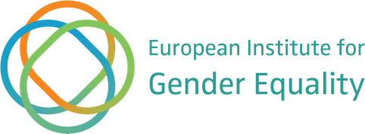

The European Institute for Gender Equality

The European Institute for Gender Equality (EIGE) produces independent research and shares best practice to promote gender equality and eliminate discrimination based on gender. As the EU agency for gender equality, we help people achieve equal opportunities so everyone can thrive, independent of their gender and background.

We combine research, data and tools to help policymakers design measures that are inclusive and transformative and promote gender equality in all areas of life. We communicate our expertise and research effectively. We work closely with partners to raise awareness. We do this at the EU and national levels and with EU candidate and potential candidate countries.

Cite this publication:
EIGE (2025), How to communicate for change. A workbook to help end violence against women. Publications Office of the European Union, Luxembourg.

Reuse is authorised provided the source is acknowledged, the original meaning is not distorted and EIGE is not liable for any damage caused by that use. The reuse policy of EIGE is implemented under Commission Decision 2011/833/EU of 12 December 2011 on the reuse of Commission documents (OJ L 330, 14.12.2011, p. 39, ELI: https://eur-lex.europa.eu/eli/dec/2011/833/oj. Unless otherwise noted, the reuse of this document is authorised under the Creative Commons Attribution 4.0 International (CC-BY 4.0) licence (https://creativecommons.org/licenses/by/4.0/). This means that reuse is allowed provided appropriate credit is given and any changes are indicated.

Luxembourg: Publications Office of the European Union, 2025

© European Institute for Gender Equality, 2025

PDF ISBN 978-92-9486-313-3 DOI:10.2839/9851095 MH-01-25-049-EN-N

European Institute for Gender Equality
Gedimino pr. 16

LT-01103 Vilnius
LITHUANIA
Tel. +370 52157444
Web: eige.europa.eu
Email: eige.sec@eige.europa.eu

Follow us





